ACTION FOR RURAL DEVELOPMENT ORGANISATION (ARDO)
WANGJING, MANIPUR- INDIA

Annual Report for the year
2023-24

RESPONDING TO CONFLICT SITUATION IN THE STATE

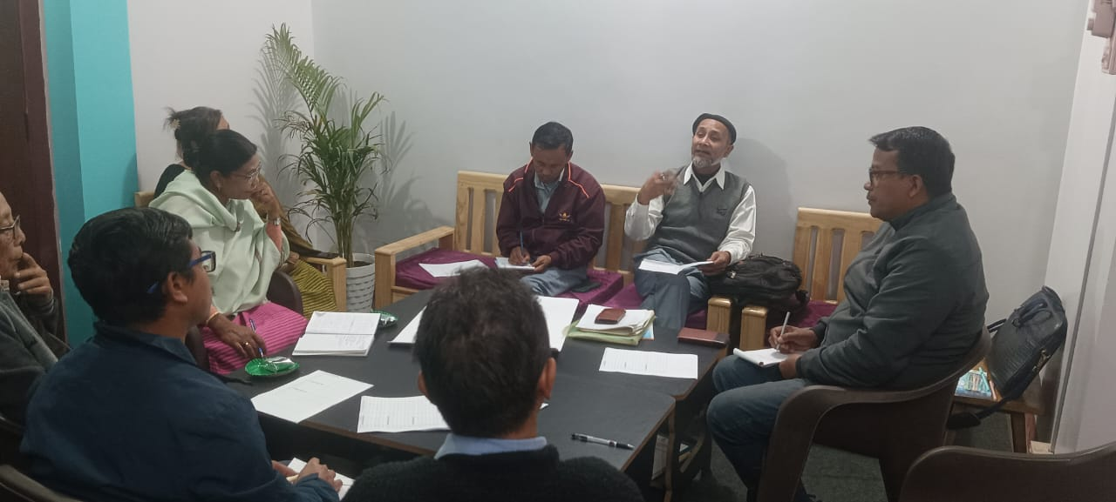
On 3rd May 2023 conflict started between Meitei and Kuki. Loss of hundreds of lives, thousands of houses, livestock and properties for both communities were witnessed. In this conflict situation, the ARDO reached out to the neutral communities who are actively engaged so that their inputs and thoughts can be reached to the leaders of both the conflicting parties to reduce the conflict. The role and responsibilities of the community leaders of both the parties from Kakching district are also important to understand by all the stakeholders. They took their shared responsibilities to connect the conflicting groups and form a conducive environment so as to reconcile, retreat, resettle and finally come to the normal livelihood situation once again in a better admosphere and better Manipur. On the other hand ARDO extended immediate relief aids to the internally displaced persons who have run out from Sugunu and Moreh on 3rd May 2023. The members of Action for Rural Development Organisation initiated campaign for extending support to meet the basic requirements of the IDPs and distributed relief materials covering woolen clothes for children, mattress, shirts, text books and khatas to students Most of them were from Moreh and taking shelter at Kodompokpi relief Camp of Wangjing. In a joint collaboration with Action for Rural Development Organisation, CCEF school and Indian Doctors for Peace and Development (IDPD) , Manipur Chapter, Free Health Camps were also organized in two spots namely at CCEF school and Wangjing Kodompokpi relief camp. The camp was led by Dr. Rajaq, Imphal Hospital.

COMMUNITY BASED AWARENESS BUILDING ON WATER AND SANITATION
The awareness building on water and sanitation is a campaign to educate rural communities on the importance of safe water and sanitation practices. The campaign, was conducted for a period of six months reaching 10 villages with the coverage of 3000 population. Through a combination of awareness campaigns, training sessions and face to face interaction among the communities, water user groups and students help improved access to clean water and sanitation facilities, reducing the incidence of water borne diseases and water recycle of grey water in households level. The programe were conducted in collaboration with Eco-club, Heirok . Access to safe water and sanitation is a fundamental human right. However, many rural community members seems to be lacking of building awareness about the importance of water and sanitation practices, may be because of giving more priority on searching jobs which may generate immediate income in the family. The main objectives of the program are to;
- Generate sense of awareness among the community members and students about the importance of safe water and sanitation practices.
- Improve access to clean water and sanitation facilities.
- Reduce the incidences of water borne diseases.
MOBILE HEALTH CARE SERVICES IN HILL AREAS OF CHANDEL AND TENGNOUPAL DISTRICT
The Mobile Health Care service project aimed to provide accessible and affordable health care services to remote hill areas. Hill areas face significant challenges in accessing health care services due to geographical constraints, lack of infrastructure, and limited availability of health care facilities. Organization of periodical health camps in such remote areas helped access to health services by the tribal communities. The district authorities and concern medical department need to review the challenges of the rural tribal communities for better facilities. Many remote villages till today do not have access to proper medical facilities, forcing residents to travel long distances to reach the nearest healthcare centers. This results in delayed treatment and a lack of preventive care for many individuals, which ultimately impacts their overall health and well-being. The shortage of healthcare professionals in rural Manipur worsens the situation, as many medical workers prefer to work in urban areas with better infrastructure and career opportunities and better transport facilities. This leaves rural communities underserved, with few healthcare providers available to meet their needs. On 3rd April 2023 we organized a free mobile medical camp at Inganglok at Konaitong and Thamlai under Machi Block under Tengnoupal District in collaboration with District Hospital Thoubal District. 300 patients with different health issues were givem medical treatment. And many medicines were distributed as per doctor prescription. The main objectives for these medical camps are:

- Provide accessible and affordable and health care services to this area
- Improve health outcomes particularly for vulnerable populations such as women, children and the elderly.
- Strengthen the exciting health care system through capacity building and referrals.
- Provided a range of health care services, including consultations, vaccinations and referrals
The Action For Rural Development Organization also took awareness building and organized Health Hygiene in villages where the government facilities are not adequately available.Free mobile health care services in collaboration with Indian Doctors for Peace and Development (IPDP), Manipur Chapter conducted free mobile Medical Camp at Pallel and Chandolpokpi villages under Kakching and Chandel district. This health camps and services helped the communities to access health care needs.Though the Health service The condition of health services in such remote hill areas is really pathetic and people are simply helpless in absence of such services. The situation is more vulnerable in case of children and aged population.

STUDENT CAREER COUNSELING TO YOUTH LEARNERS
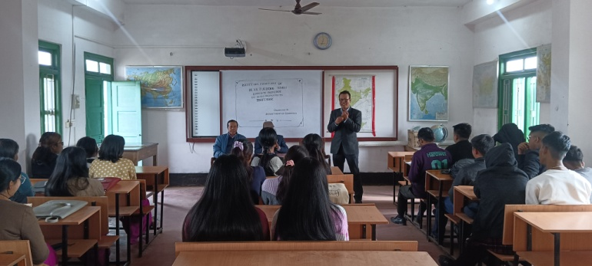
Carrier choices play a crucial role in shaping a student’s future. However, many students lack guidance, leading to uncertainty and poor career decisions. This project aimed to provide young learners with comprehensive career counseling. ARDO organize two days student career counseling program on 15th January 2024. Students from Colleges were invited for the counseling session. The main objectives of pregame are:
- Provide students with a clear understanding of their strengths, interests, and values.
- Expose students to various career option and their requirements.
- Equip students with the skills to make informed career decisions.
The career counseling project demonstrated the importance of guiding career choices. By providing comprehensive students to make better career decisions, ultimately shaping their future

BRINGING WATER USER COMMUNITIES TOGETHER FOR CONSERVATION AND PROTECTION OF FOREST WANGJING RIVER CATCHMENT AREAS:
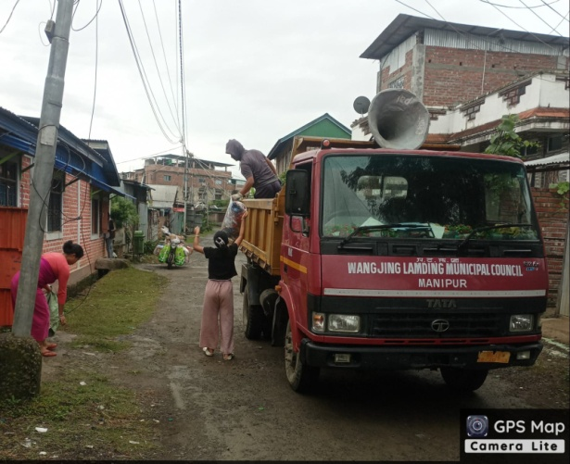
ARDO mobilizes, organizes and engages with local communities of Wangjing river basin to have a consensus for building strength for formation of Basin level Management committee to regulate water and conserve the deteriorating forest resources in the catchment areas. It has already been aware the scenarios of loss forest covers and soil erosion which have affected communities living in both upper stream and downstream. It is a step forward to jointly work with village community members in managing water resources and forest based conservation measures in the catchment areas. The settlement pattern is linear in nature concentrating in two different spatial locations. The village is extended in East West direction guarded by Konaitong hill ranges in the north and Karongthel hill range in the south. The Heirok River runs along the foot hills of Karongthel in east-west direction serving the entire Heirok, Wangjing, Cherapur, Sangaiyumpham and Tentha and finally merged to Kharung pat. There has been issue of deterioration of water quality due to dumping of waste products in the riverside. Local Clubs in collaboration with ARDO have been continuously motivating and providing learning support on solid waste management with the support of Local Municipal Council Heirok and Wangjing .

EMPOWERING WOMEN THROUGH CREDIT SCHEMES FOR SKILL DEVELOPMENTS PROGRAMME AND RURAL LIVELIHOOD ACTIVITIES
Promotion of Handicrafts Development Through women Self Help Group
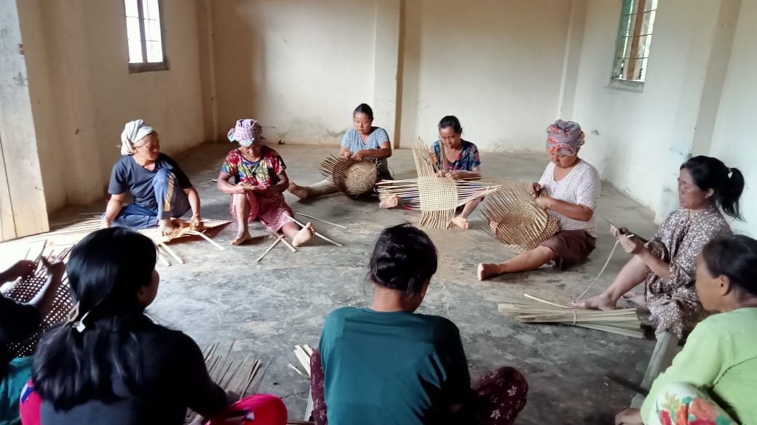
Handicrafts are an integral part of our cultural heritage,but their preservation and promotion are threatened by urbanization and globalization. Women Self Help Groups (SHGs) in the state offer a unique opportunity to empower women while preserving traditional handicrafts. Through selling of handicrafts items designed by such small women Self Healp Groups, they are able to management their requirements for children education, health, maintaining day to day family affairs. On date 13 December 2023 one day’s seminar pregame is conducted at Komlathbi Village, Chandel district, Manipur This Seminar pregame aimed to promote handicrafts and raising rural Economy . In this seminar 50 candidates were participated.
The main Objective of seminar is:
- Empower women: Enhance the economic and social status of women through SHGs.
- Preserve Heritage: Promote and preserve traditional handicrafts.
- Improve Livelihood’s: Increase the income of participating women through handicraft sales.
The project demonstrated the potential of women SHGs in promoting handicrafts development and improving the rural livelihood means. By providing training, raw materials and support market linkages and empowered women folks to preserve traditional handicrafts and enhance their economic status

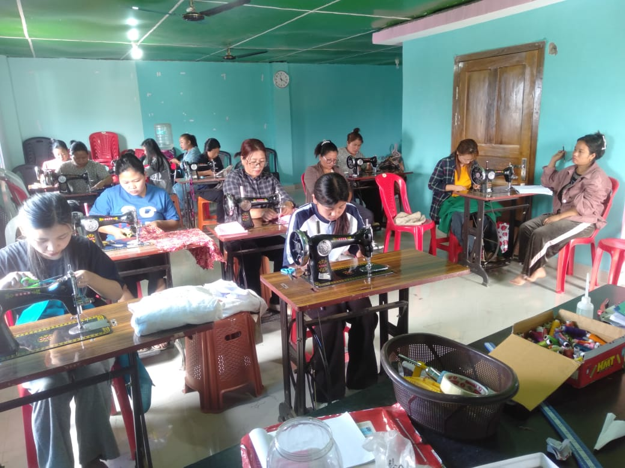
The Action For Rural Development Organisation(ARDO) encourage young women and girls who were out of school and college formal education due to one or other reason (s) Vocational education is to acquire skills for illiterates,neo literates and school and college drop outs population to enable them to adopt a skill job earning their livelihoods or living. Vocational education was a part of school education so as to undertand the students ackquire such knowledge. The Action For Rural Development Organization observes two types of unemployment structures; unemployed due to lack of skill knowledge and unemployed due to poverty. The situation was further, reviewed and the society thought that the vocational skill development training can be one of the measures to provide employment to the young women and girls in the society. With the collaboation with JSS Thoubal and Chandel district, the Action for Rural Development Organisation conducted the following training courses
JSS, Chandel | JSS, Thoubal | Nos of trainess
Computer | Tailoring | 40
Handloom & Handicrafts | Fruit preservation | 40

IMPROVING COMMUNITY ECONOMY THROUGH LIVESTOCK REARING
Piggery :
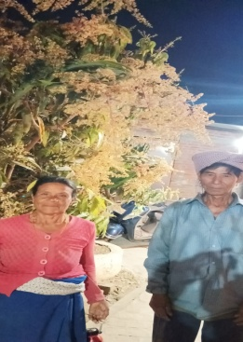
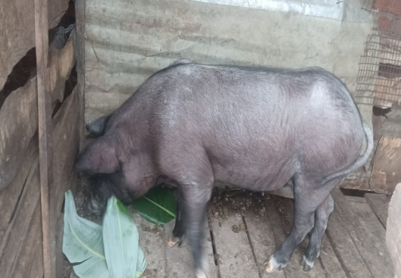
Piggery is one of the most successful income generating activities promising a good income of the poor families. Smt sorokhaibam tombi Devi 70 years old women wife of Sorokhaibam Manikhomdon singh aged 75 years from Wangjing Khabakhong maning leikai started pig farming since the aged of 50 years after hard struggle of life with 6 children. The family was surviving on the daily wage received from the daily engagement of service in the locality for any sort of activities of others. With the little amount received from work, they managed the family. Smt Tombi was informed by a woman SHG in the locality to join the group and was explained the opportunities offered in the group. In a planning session, she had chosen piggary. She got two piglets in the form of loan. 5 months later, the two pigs given birth 15 piglets. 5 piglets were given back to the sponsor NGO and 10 piglets were become her income. The market value during that period of time for 10 piglets and two mature mothers were Rs.33000 (10x 1700= 17000+ 8000x2=16000). As such she is still continuing the pig rearing as her constant source of income. Her children also grown up and started working. One of her children joined government service. The policy of piglet distribution was self preparation by the women SHGs .
SCHOOL PROJECT
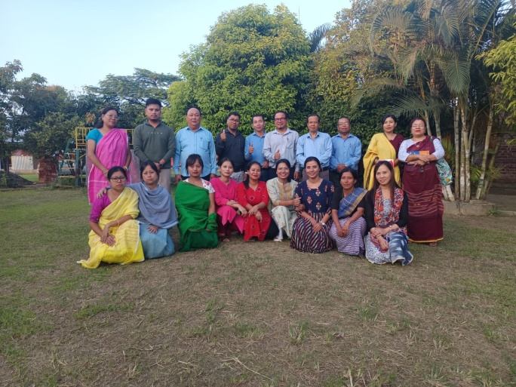
Education is main thrust areas of ARDO.We in ARDO believe that education is to provide the children that type of education with a learning environment which bring out the best in them and able to expand their horizon of knowledge and understanding. Every child is endowed with a unique set of attributes and abilities which need to be nurtured so that their knowledge can be expanded. Therefore every student deserves an education that fosters academic excellence and all round development and ensures their well beings in the society. The School “The Child Care And Educational Foundation –CCEF” which was started in Nov 2010 has been able to accommodate 350 students and it has been promoted upto X standard. Salient features of the school are; Co-Educational Institution, a homely located place with green cover of trees, 1:30 ratios as indicated in 2020 NEP, mentorship and 24 hours CCTV surveillance system.
Co-curriculam development Activities
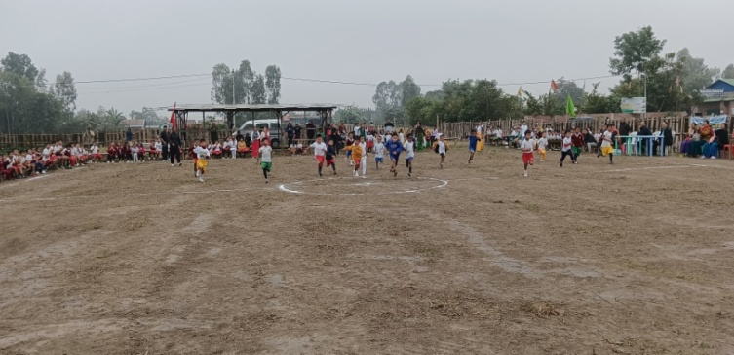
Integration of Local Arts form and cultural practices in school education considerably low while having ideas and interest to promote such practices in both govt and private schools .the ARDO has taken a decision in 2022 board meeting to introduce these local art forms in school syllabus to encourage students in acquiring skill and knowledge on traditional local art forms. The main objective is to develop better learning environment for the students though instigation of traditional knowledge of local art forms The school introduced Arts activities in 4 streams. Thang Ta , music , Dance and Drama. Introduction of these four streams of art forms helped students expanding their diversified skill and knowlegde and able to contribute to choosing their area of interest for better academic future. Annual sports, Cultural meet programme of the school certainly contributed toward building confidence of students thereby enabling them increasing personality and competence among them.
Free Education programme for Internally displaced students to CCEF
The ARDO has been continuing sponsorship programme for IDP students for their continuation of academic carrier. 10 students have been provided free education facilities. Most of these students were from Moreh under Tengnoupal district of Manipur. The free Education covers School admission, monthly fees , uniforms, books and note books and Boarding cost.
CAPACIRY BUILDING TRAINING FOR TEACHERS
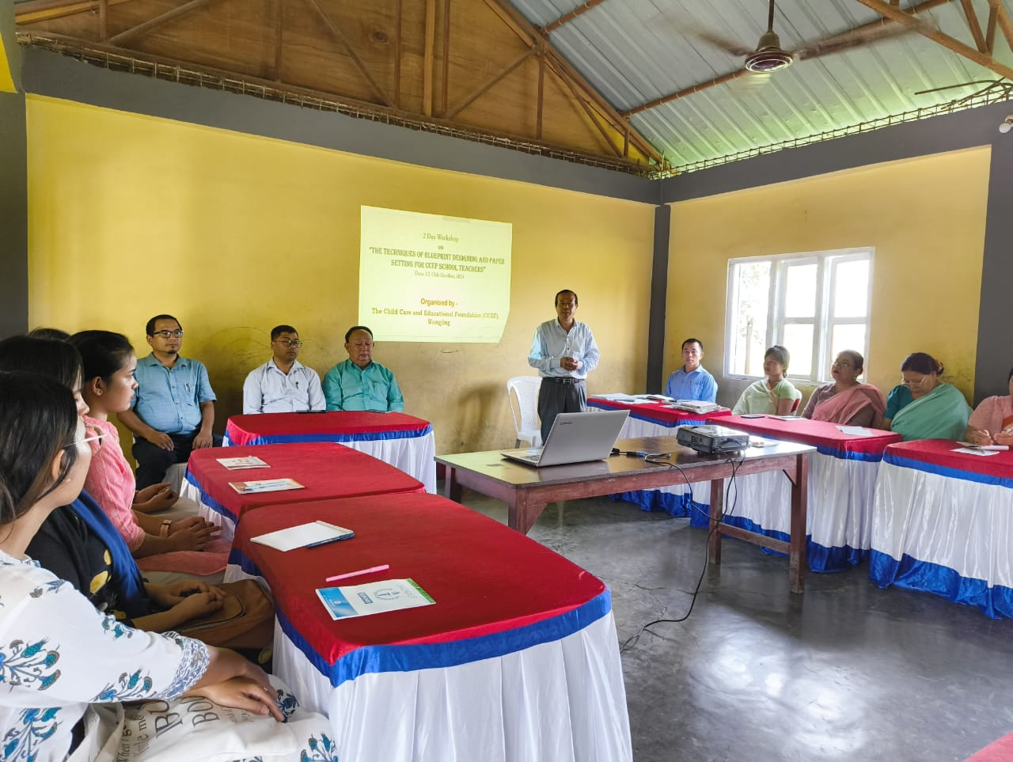
Building the capacity of teachers is essential to achieve the quality of education and academic experience of the teachers. The key is to provide children with the tools to think for themselves. To do so, we instil a sense of commitment in teachers and ensure that they have the skills to bring the best out of children while understanding the varied learning methods required meeting the needs of every child. Through extensive regular capacity building, teachers receive trainings on student-centred teaching methodology, social and emotional learning as well as trainings that enable them to make effective use of equipment, teaching aids and technology to ensure that each child gains as much as they can from the learning centre. ARDO school project help to bring significant changes in the rural community members in terms of setting priorities through periodical consultation meeting with management authorities of the organisation.Children performances in the periodical examinations indicate collective continuous efforts of parents and teachers. Such hands on Training of the teachers have been instrumenting the development process of the school. This year the experts from Manipur University had facilitated on Micro teaching, and technical skill in deliberation of teaching learning exercises on the school education. The expert from INGNOU centre, Imphal also facilitated on NEP 2020 and teachers role in implementing this policy and challenges.

STUDENTS COUNSELLING
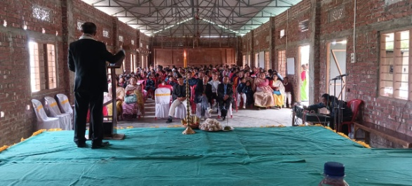
Number of youths used in illicit drug trafficking and abuse of such substances has been increasing in the society. Through this process, their friendship with new one in new areas is also being expanded. The role of parents, teachers and other members in the locality is paramount important in guiding and maturing these potential youths to streamlining their future. Periodical counseling to these young students along with their mothers were organized and shared internal ethos of our ideas while building a informed citizen in future.
WORLD ENVIRONMENT DAY 2023
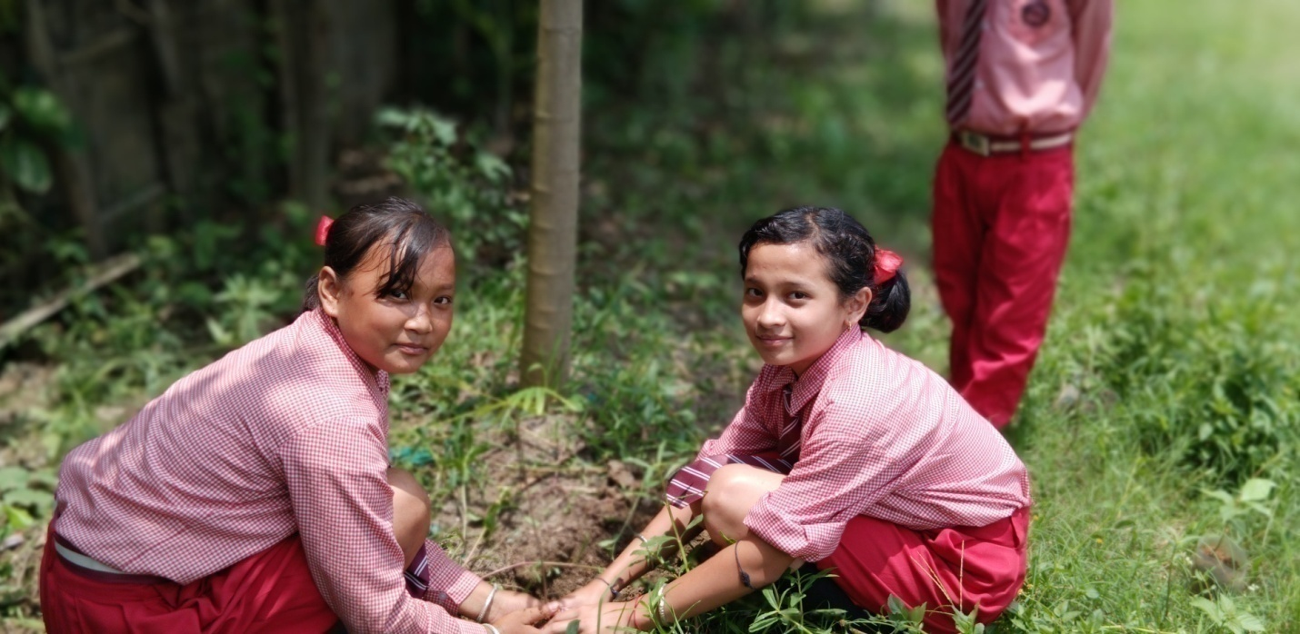
The world environment Day 2023 was organized on 5th June,2023 with the theme “Only One Earth” focusing on living sustainability in harmony with nature. Children are the agents to transform our society for better living. Their involvement in such campaign create impacting increased awareness among the community members Therefore ARDO celebrate World Environment Day 2023 though tree plantation and restoration of health environment drives in partnership with school children.

PATRIOTIC DAY OBSERVANCE 2023
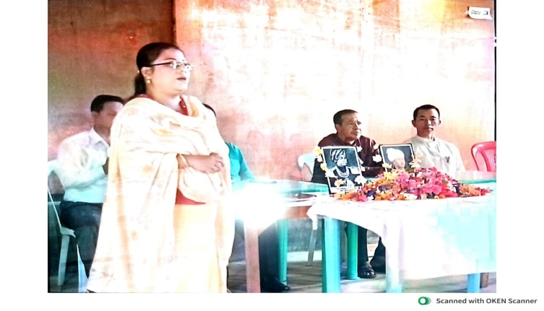
Promotion of sense of patriotism and nationalism among the people particularly the school children has become a paramount important need in the present society. Every year, the Action for Rural Development Organisation in collaboration with the Child Care and Educational Foundation (CCEF school) Wangjing organised Patroitic Day 2023.On this day children and school teachers conducted prayers to the departed soul of the brave leaders of the Bir Tikendrajit and Paona Brajabashi. They were fighting to save the motherland and sacrifice their life in the battle between Manipuri King and British army.

